

USER MANUAL

*IOS Mobile*

*Application*

**Telugu Churches**



**General Information:**

**Telugu Churches** provides iOS App for iOS users, which helps to view about the churches, authors and events information along with online shopping and careers portal .**Telugu churches** application is available in Telugu and English languages. The following document will show you how to install and enjoy it.

**Application Overview**

Telugu Churches has been developed by Calibrage Info Systems India Pvt Ltd.Telugu Churches is a blog which contains the information of registered churches and registered pastor’s. This application contains the audios, video’s, quote’s, careers, online shopping and events of the registered churches and pastors. Registered users can apply for the job and user can buy products from here. Whenever the new posts and events will be added, registered users will get the notification only for successfully subscribed churches or pastors. In this application posts are divided into different categories. Registered Users will have a chance to like, dislike, share and comment the posts. User can read the complete bible in both English and Telugu Languages. Registered users can view and edit there profile.

**Hardware and Software Requirements**

Requires a smart phone with iOS operating system (OS).

The minimum iOS version should be 8.0 or above to enjoy all the features in the application.

To download and use the functionalities of Telugu churches mobile app, you require an Internet connection in your mobile.

**User Access Levels**

There are two types of roles in Telugu churches mobile application.

* 1. Regular User
  2. Registered User

**1. Regular User**

Guest user is one who can access the below features of Telugu churches application without registering in the application.

* User can view information about the churches and the pastors.
* User can view the audios, videos, images and documents.
* User can read the Bible.
* User can view complete information about the events.
* User will able to see all kinds of posts.

**2. Registered User**

Registered user is one who registers himself/herself in the Telugu churches application can access the below features of Telugu churches application.

* User can view information and subscribe the churches and the pastors.
* User can view all kinds of posts and user can like, dislike, comment and share the audio’s, videos, images and documents.
* User can read the Bible.
* User can view complete information about the events and user can like, dislike, comment and share the events.
* User will able to see all kinds of posts.
* For subscribed churches / pastors, user will get the notification for newly added posts.
* User can see the careers and apply for the job from application which are posted by churches.
* User can see the products (books, DVD’s, articles, etc.…) and buy the products from application which are presented by churches.
* User can update his/her profile.

**How to download the application**

**Telugu churches** application can be downloaded through App Store.

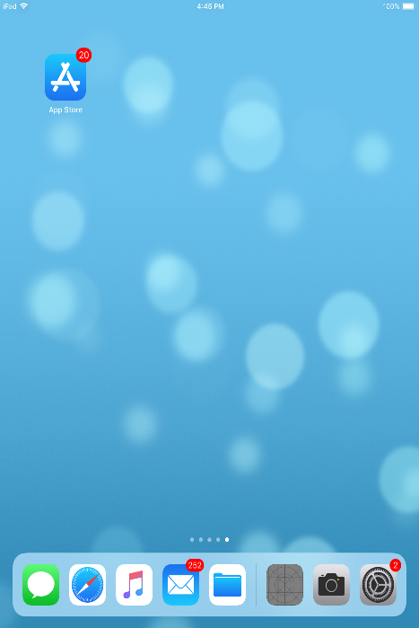

**App Store**

Open **App Store** application on your mobile by clicking on the App Store icon as shown in the image below.

Click on the search option at the top and enter the text " **Telugu churches**" in the search bar. Click on the **Telugu Churches** application icon from the search result. Now page will open which asks to install the application. Click on the "INSTALL" button to install the application.

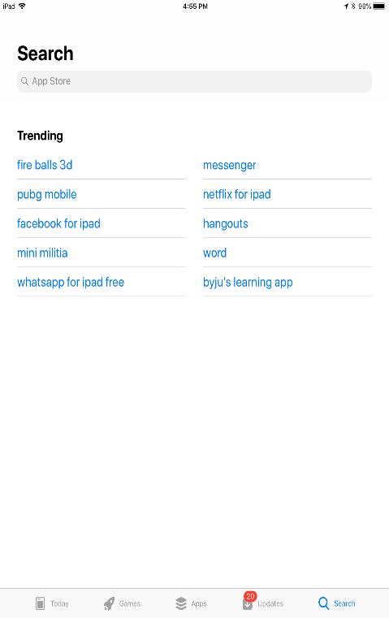 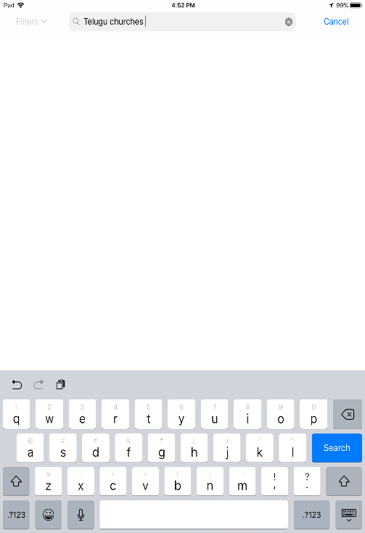

**View Home Page**

Launch the application by clicking on the **Telugu Churches** icon on your mobile as shown in the image below.

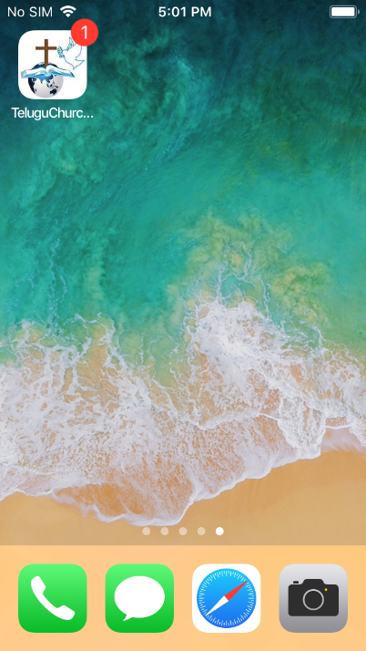

While launching the application Splash screen will be appear, in this screen daily quotes will be updated as shown in the image below.



As soon as **Telugu Churches** application is launched, Home page will be displayed which shows the banners, upcoming events of the coming week, Cart items of online shopping, Notifications with count and the categories of posts as shown in the image below.

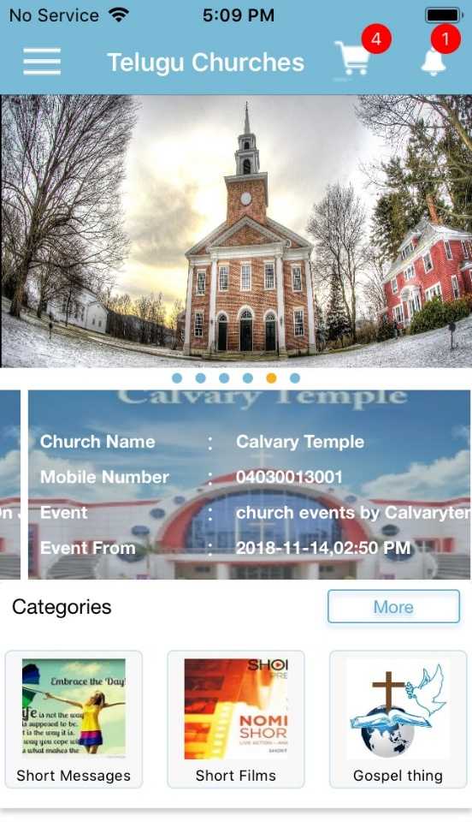

More Button to View All Categories

Categories

Upcoming Events

Notifications

Menu

Banners

Cart

**Side Menu :**

Side menu contains complete options related to Telugu Churches.

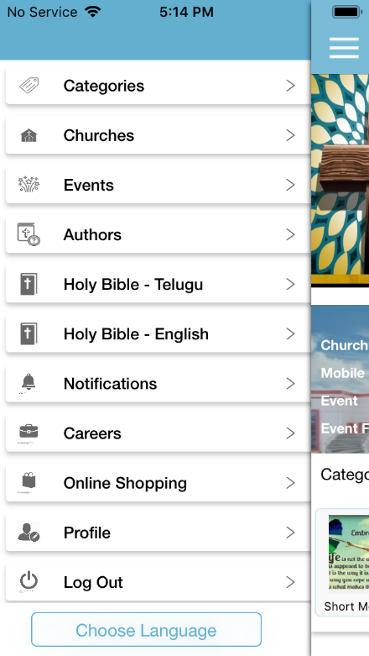

**Categories:**

All categories list will be displayed after navigating from home page when we click on more button or selecting category option from side menu. Search is available to search categories.

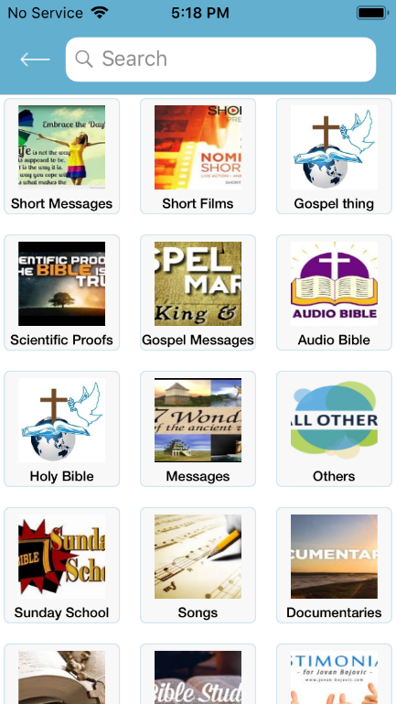

Search

**Categories Detail:**

After selecting a specific category, Audio's, Video's, Images and Documents of that particular category will be displayed.

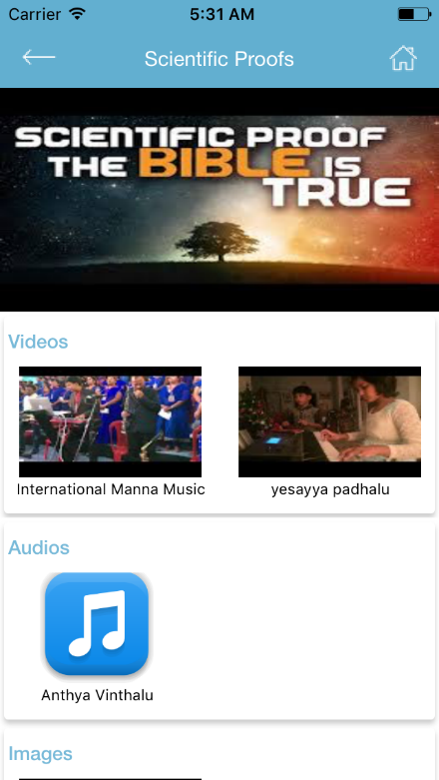

After selecting on particular Post, Video/Audio/Image/Document, Registered user can View, like, dislike, comment, Subscribe and share the post.

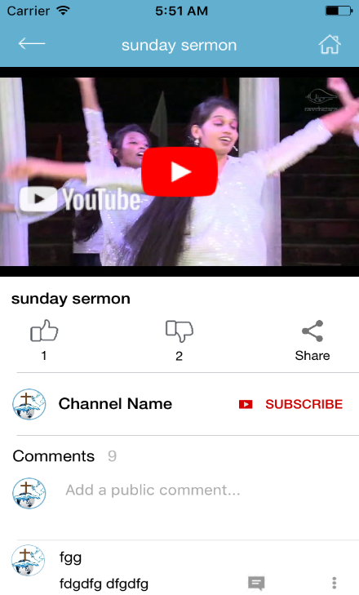

Comments

Subscribe

Share

Like

Dislike

**Churches:**

All churches list will be displayed after navigating from home page when we selecting church option from side menu. Search is available to search churches.

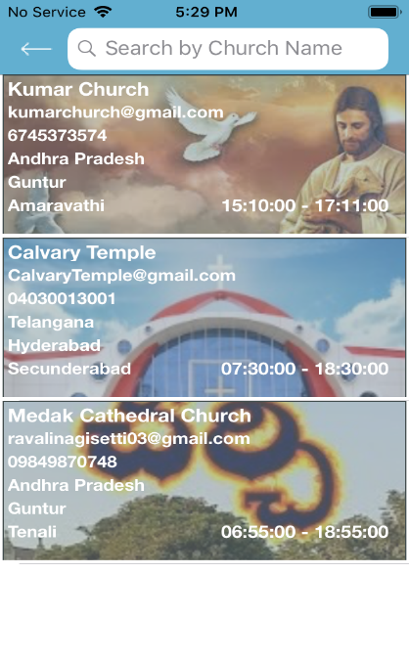

Search Churches

Church information

**Church Details:**

After selecting the specific church, Selected church Information, Events, and posts of the church will be displayed. Church location will be displayed in maps. Registered Users have a chance to subscribe the particular church. After successful subscription, user will get notifications for particular church posts and events. Selected church events, and posts of the specific church will be displayed here.

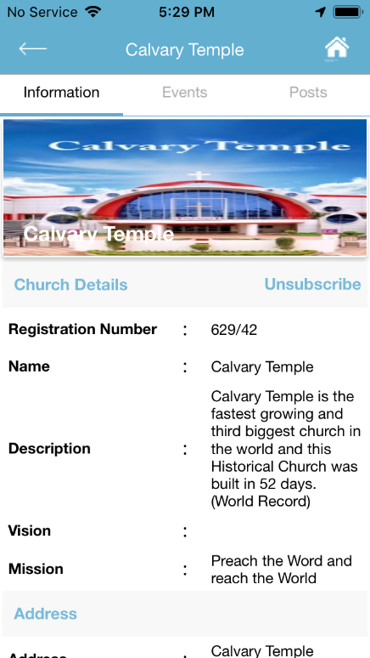 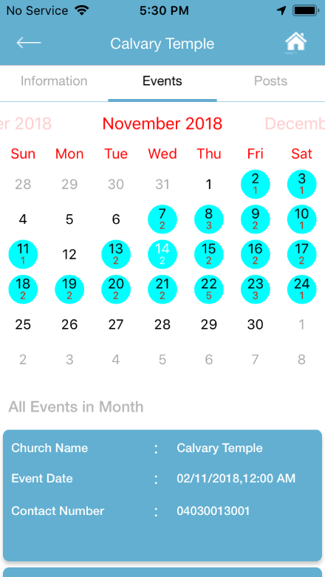 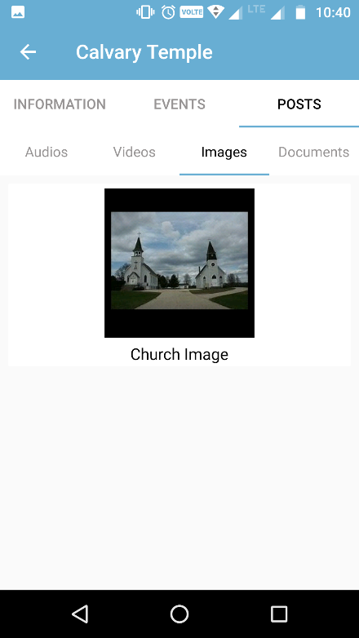

**Events:**

User can view upcoming events of coming week and all events here. After selecting specific event,details and posts will be displayed here. Registered user can like/dislike/share/comment the event here.

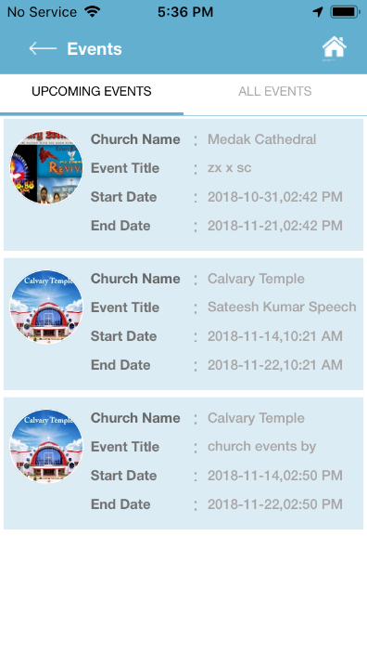 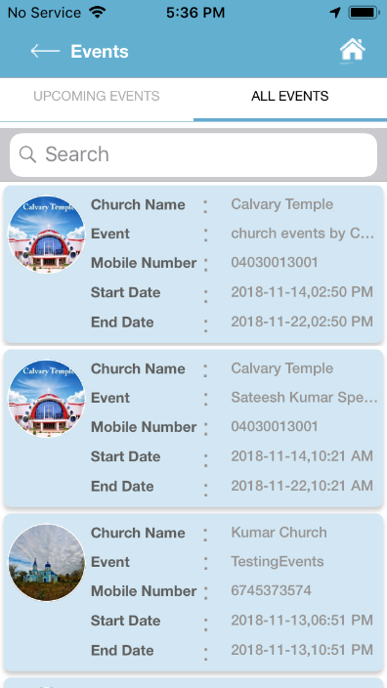 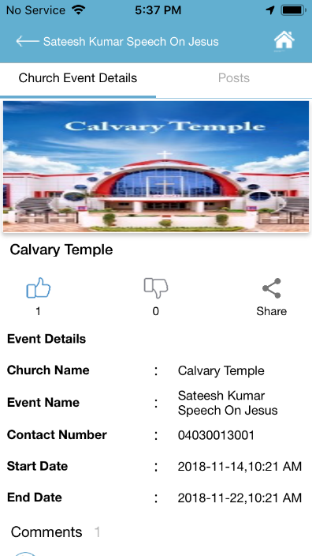

**Authors:**

All Authors list will be displayed after navigating from home page when we selecting Authors option from side menu. Search is available to search Authors.

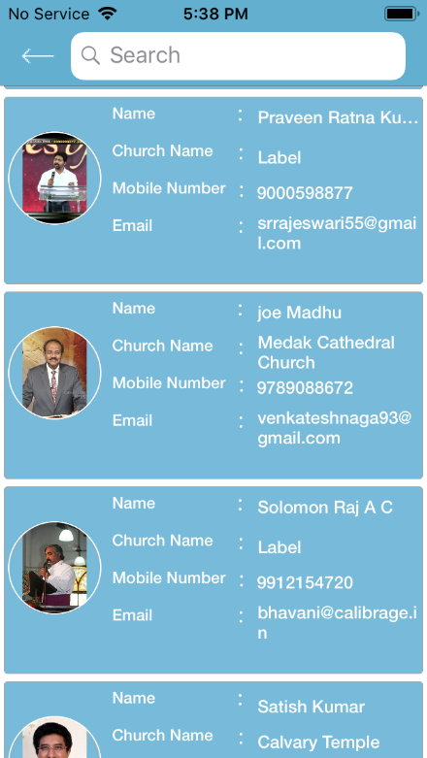

Search

Author Information

**Author Details:**

After selecting the specific Author, Selected Author Information, Events, and posts of the Author will be displayed. Registered Users have a chance to subscribe the particular Author. After successful subscription, user will get notifications for particular Author posts and events. Selected Author events, and posts of the specific Author will be displayed here.

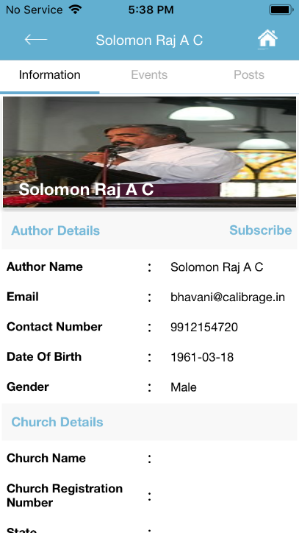 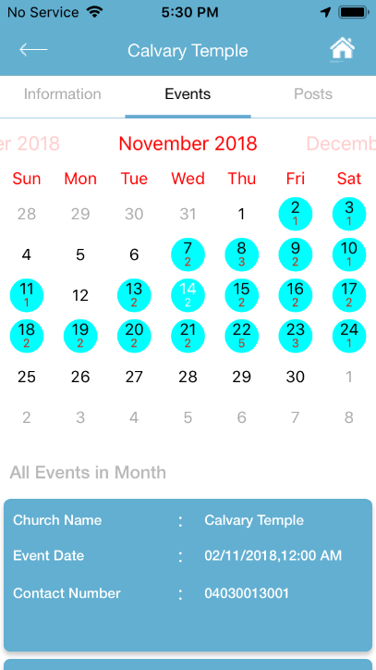 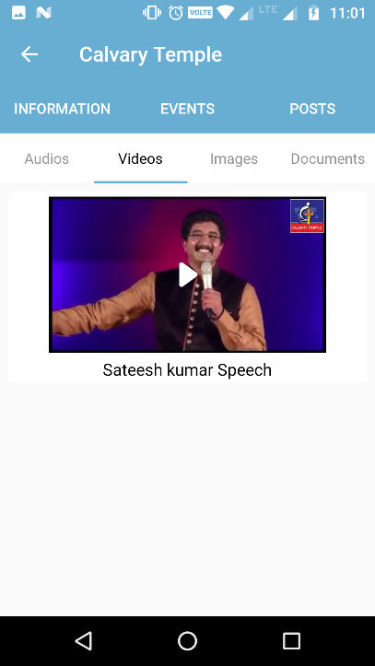

**Holy Bible – Telugu/English :**

Previous Chapter

Here user can read the Holy Bible in Telugu/English Languages**.**

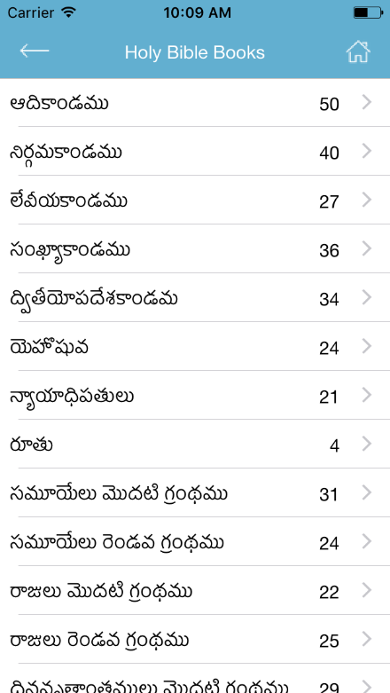 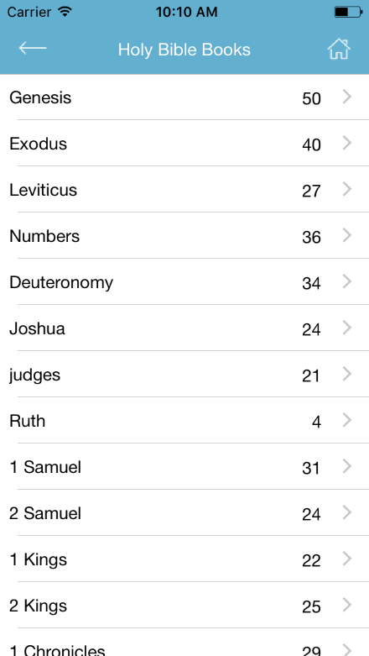 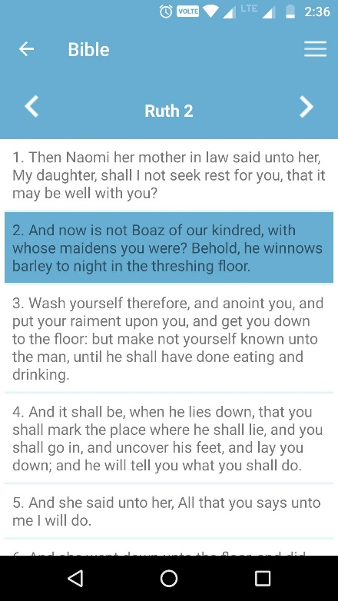

Next

**Notifications:**

Here the user can view the New and Read notifications of subscribed authors, churches, posts and videos. By selecting on particular notification, page will be navigated to specific page depends on selected notification.

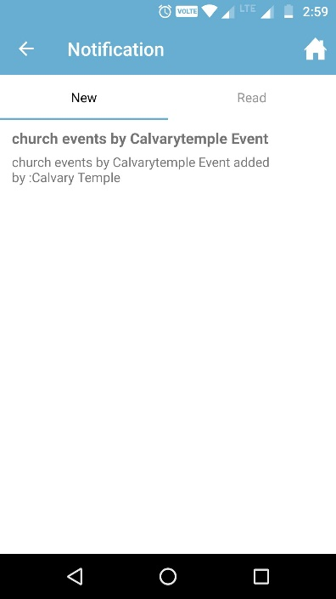 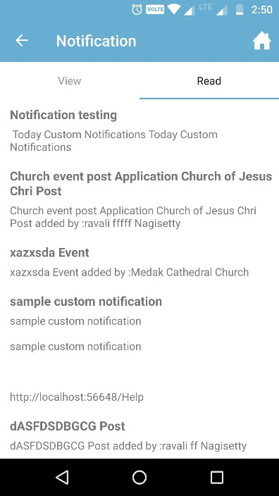

**Careers:**

Careers list will be displayed after navigating from home page when we selecting Careers option from side menu. If church admin or portal admin will post the careers, those will be displayed here .After selecting particular career only registered Users can apply for job from here.

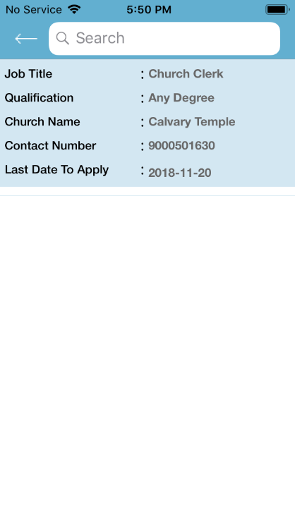 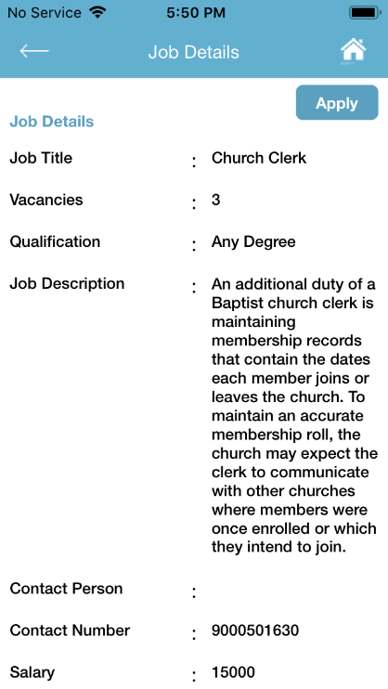

Job Details

To apply Job

Career Information

**Careers Apply:**

To apply for the particular job, the user needs to fill the required details. Along with the details user must have to upload the resume.

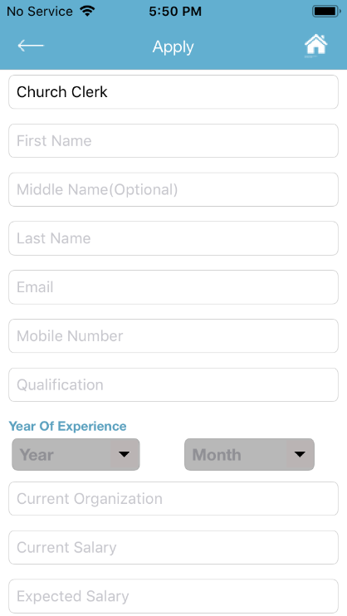 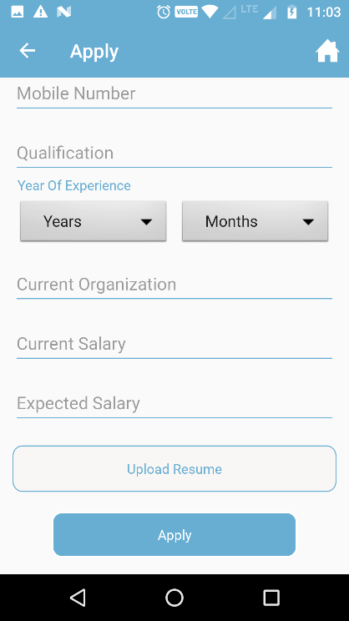

Resume Upload

**Online Shopping:**

If church admin or portal admin wants to sell the products, those will be added from the portal, that added products will be displayed here. User can buy any kind of product from here.

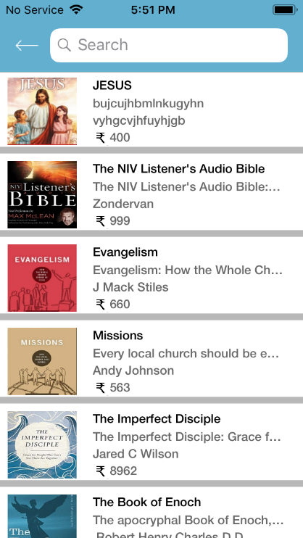 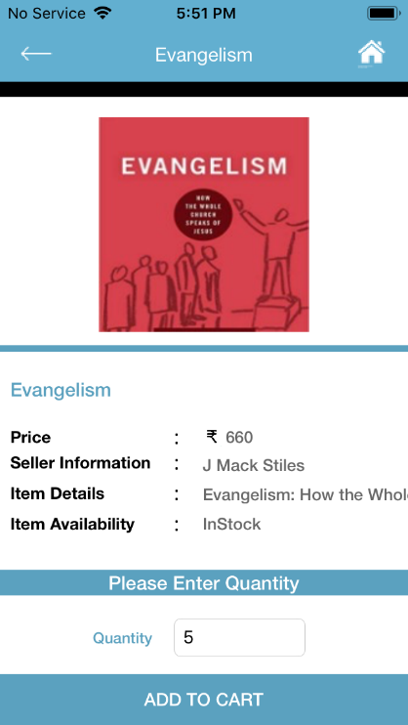

Quantity

Add Items to cart

Items List

Item Details

**Add to Cart:**

To buy the selected products, User need to add the products to cart by clicking on Add To Cart button. If the user wants to buy more than one product, user has to add products to cart, then user can see the selected products list in this page. User have a chance to delete item from cart.

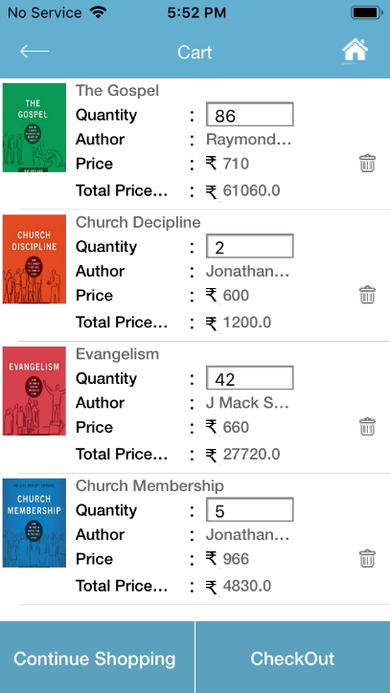

To pay for Product

To Delete the Items from cart

Cart Items

**Checkout/Add New Address:**

After clicking on checkout button user will navigate to add address page for delivery of product. Already added addresses will be shown here. User will have the chance to add the new address by selecting add new address option, if user wants.

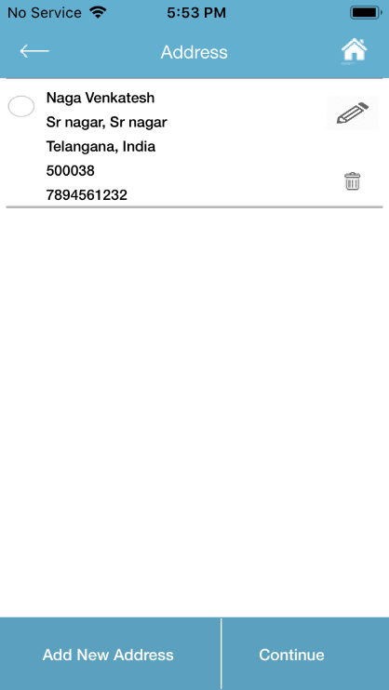 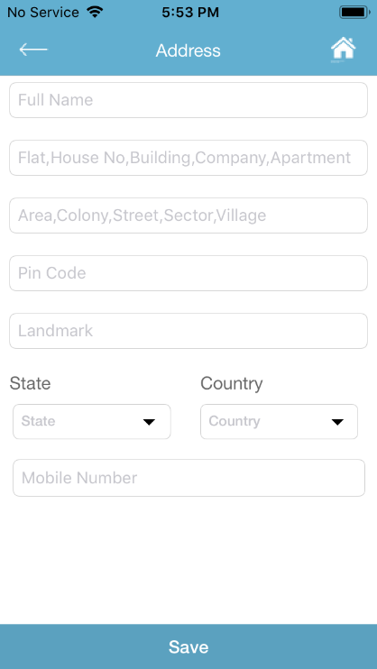

List of addresses

Add Address

Delete Address

Edit Address

**Login:**

To login into the application, User should have to use the UserName and Password whatever user will create while registration. If user is new for the application user can register himself/herself by clicking on Register button. If user forgot the password, user will get the password by clicking on Forgot Password Button

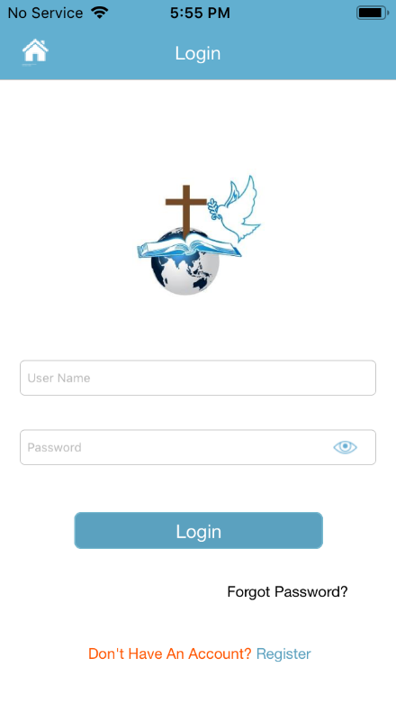

Login

Sign-Up

Forgot Password

Password Visibility

**Register:**

User needs to sign up here to login into the application.

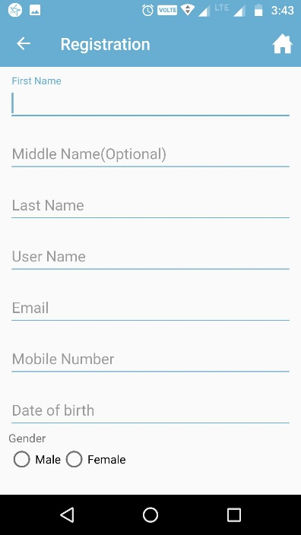 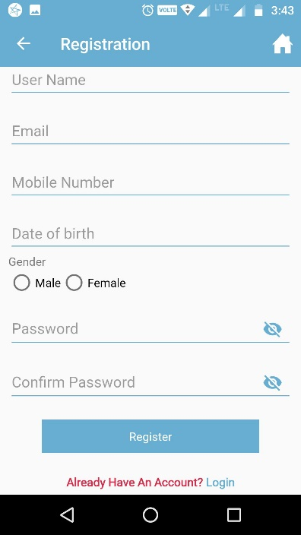

**Profile:**

By clicking on profile from Home page Menu, Users can view/edit their profile. By clicking on Edit icon user can edit the profile. User can add/change the profile photo clicking on change photo option.

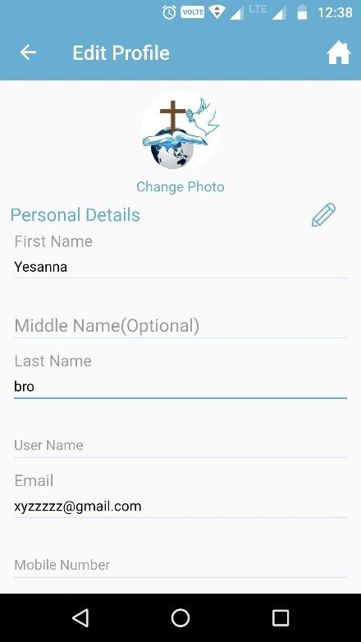

Change Photo

Edit Profile

**Change Password:**

Change Password Pop-up will be displayed by clicking on Change Password option from home page side menu. User have to enter the old password and new password.

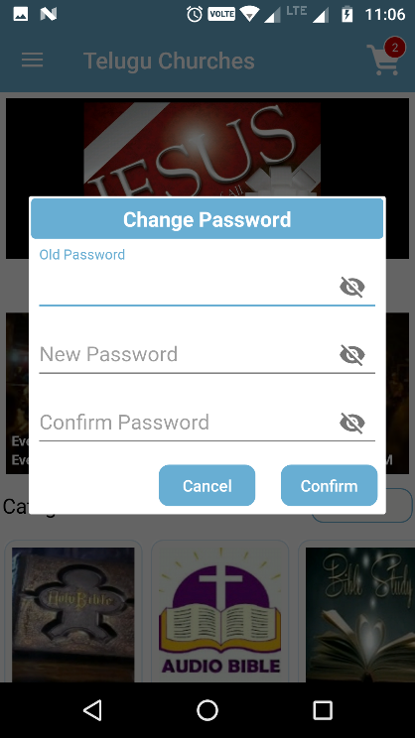

Confirm Password

Password Visibility

**Forgot Password:**

Forgot Password Pop-up will be displayed by clicking on Forgot password option from login page. User is suppose to enter his/her registered mail id.Then user will get the mail of password**.**

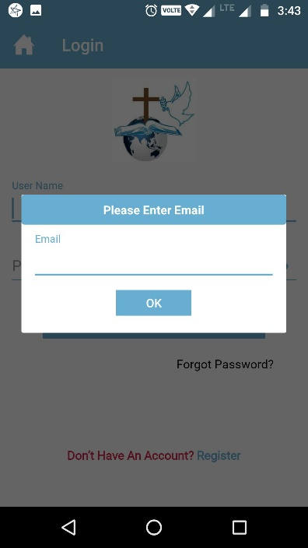

Mail-Id to be entered

**Choose Language:**

Our application is available in both Telugu and English Languages. Languages Pop-up will be displayed by clicking on Choose Language option from Home page side menu. User need to select the language.

